Hardware And Components

Assignment Day-3

Task-1: Create a comparison table listing the main differences between DDR3, DDR4, and DDR5 RAM, including speed, voltage, and typical use cases.

DDR3 vs DDR4 vs DDR5 RAM

Feature | DDR3 | DDR4 | DDR5
Generation | 3rd generation | 4th generation | 5th generation
Speed | 800–2133 MT/s | 1600–3200 MT/s | 4800–8400+ MT/s
Voltage | 1.5V | 1.2V | 1.1V
Performance | Low to moderate | Good | Very high
Power Consumption | Higher | Lower than DDR3 | Lowest among the three
Bandwidth | Lower | Higher than DDR3 | Much higher
Typical Use | Older PCs and laptops | Mainstream PCs and gaming systems | Modern gaming PCs, workstations and high-performance systems
Availability | Mostly outdated | Common | Increasingly common in newer systems
Main Advantage | Affordable for older systems | Good balance of speed and efficiency | Highest speed and bandwidth
Compatibility | Older motherboards | DDR4-supported motherboards | DDR5-supported motherboards

Task-2: Open your laptop or desktop (with power disconnected), locate the RAM slots, and take a clear photo of the installed RAM module. Reinstall the RAM module and verify that your system boots up successfully.<br><br><em><strong>Hint:</strong> Refer to your device manual or a trusted YouTube guide if unsure about RAM removal and installation steps.</em>.

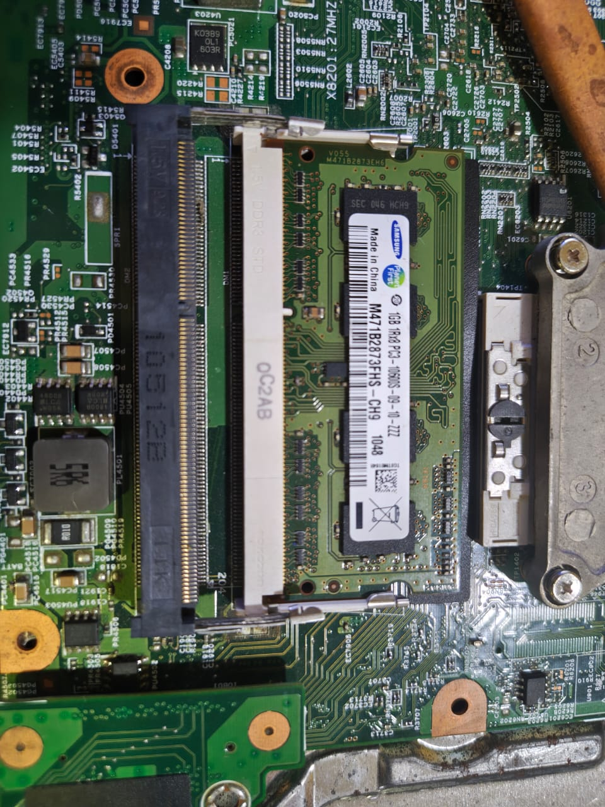
STEP 1-SHUT DOWN THE LAPTOP
STEP2-OPEN THE BACK OF THE LAPTOP
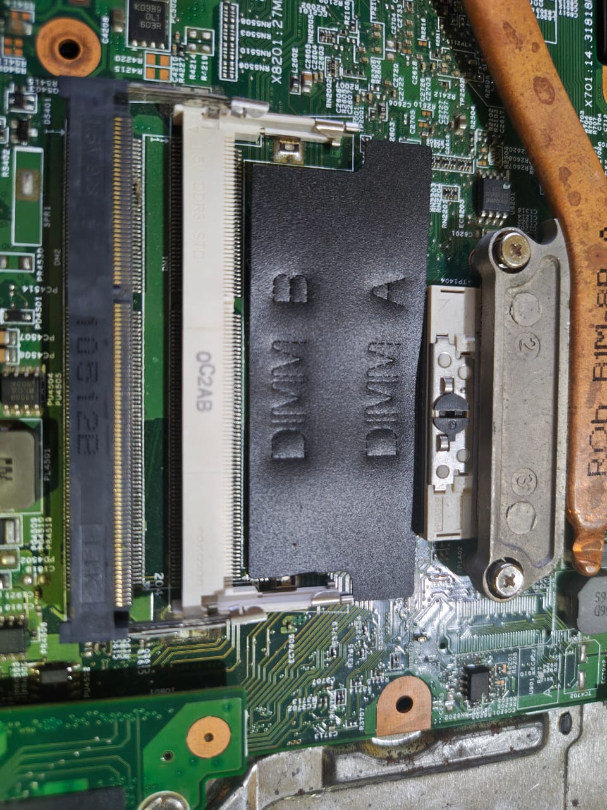
STEP3-LOCATE THE RAM MODULE(here we can find the RAM )

STEP4-REMOVE THE RAM
STEP5-RE-INSTALL THE RAM
STEP6-REASSEMBLE THE LAPTOP
STEP7-VERIFY THE SYSTEM BOOT

Task-3: List three key differences between HDD, SSD, and NVMe storage types, and for each, name one app or use case (from apps you use daily) that would benefit most from that storage type.

HDD vs SSD vs NVMe

Feature | HDD | SSD | NVMe SSD
Technology | Uses spinning magnetic disks | Uses flash memory with no moving parts | Uses flash memory and connects through PCIe
Speed | Slowest | Faster than HDD | Fastest of the three
Price & Storage | Cheaper and available in large capacities | More expensive than HDD | Usually the most expensive
Best Use | Storing large files, photos, videos, and backups | Everyday apps and general computer use | Gaming, video editing, and heavy applications
Daily-use Example | Google Drive/backup storage – useful for keeping large files and backups | Spotify – helps apps open and load faster | PUBG/Free Fire – gives faster game loading and reduces loading times

Task-4: Remove the storage drive (HDD or SSD) from your system, take a photo of the connector type (SATA, M.2, or NVMe), and reinstall the drive. Confirm that your device recognizes the storage after reassembly.<br><br><em><strong>Constraint:</strong> Only perform this task if you have access to a device you are allowed to open. If not, find and share a YouTube video link showing the process for your laptop/PC model.</em>

STEP1- Shut Down the Laptop
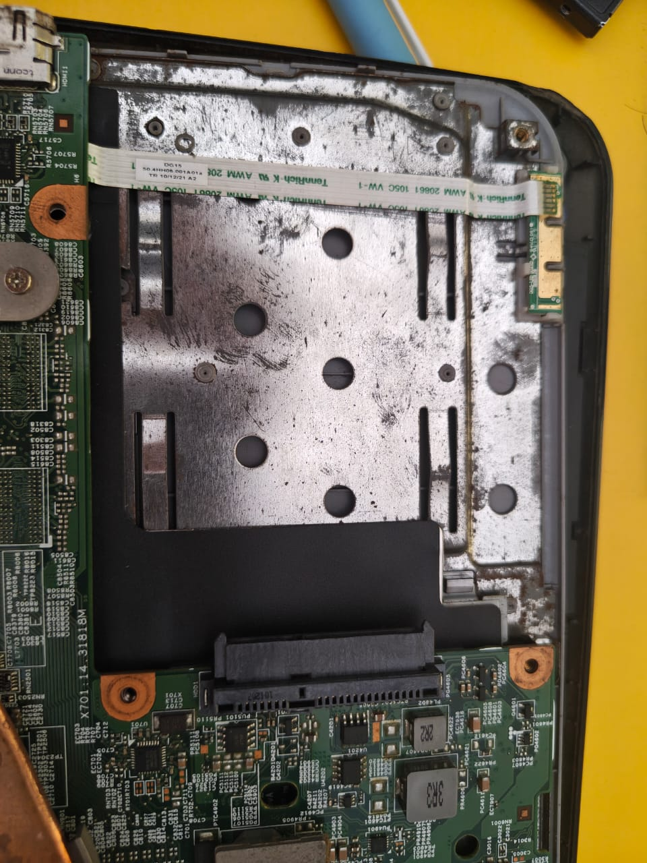
STEP2-Open the Back Cover
STEP3-Locate the Storage Drive
STEP 4-Remove the SSD

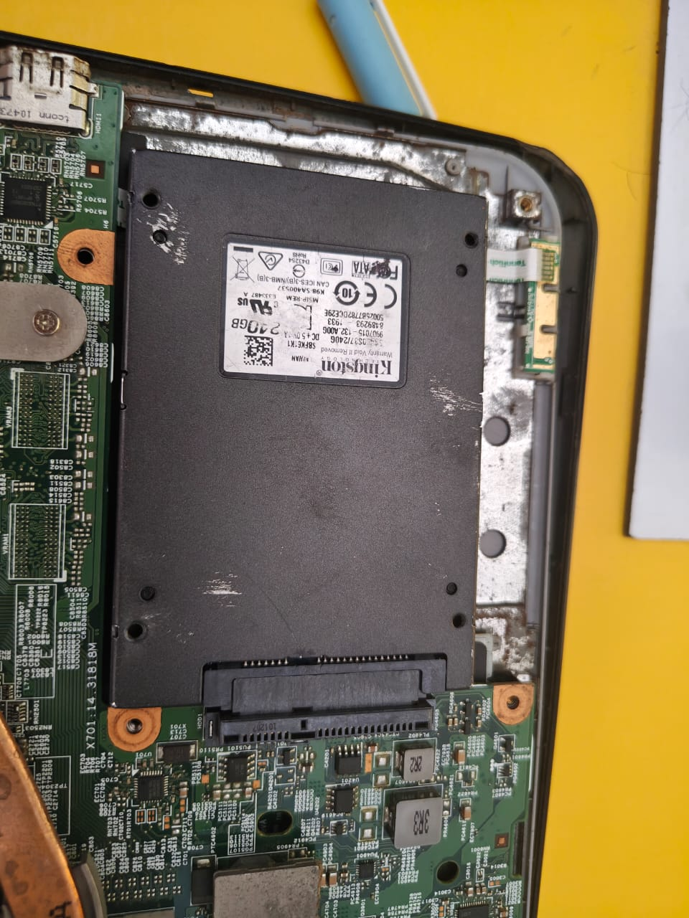
STEP5- Identify the Connector Type
STEP6-Reinstall the SSD

